Earthquake prediction model

using python

**OBJECTIVE :** The objective is to explore innovative techniques such as ensemble methods and deep learning architectures to improve the Earthquake prediction system’s accuracy and robustness also using advanced techniques such as hyperparameter tuning and feature engineering to improve the prediction model's performance.

**Data Source:** Kaggle dataset containing earthquake data with features like date, time, latitude, longitude, depth, and Magnitude

**Dataset Link:** <https://www.kaggle.com/datasets/usgs/earthquake-database>

Creating an earthquake magnitude prediction model using ensemble methods and deep learning architectures is a complex task, and it typically involves a combination of data preprocessing, feature engineering, model selection, and evaluation.

Here is a general outline of the steps you might take to build a model for earthquake prediction, with a focus on ensemble methods and deep learning architectures to enhance accuracy and robustness:

# Data Collection:

Historical earthquake data, including location, magnitude, and time has been collected from given data source.

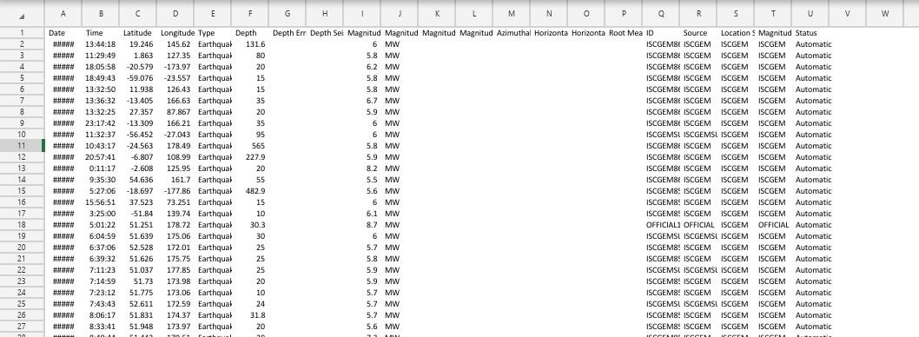

# Data Preprocessing:

Clean and preprocess the data to remove noise and inconsistencies.

*Feature engineering:* Extract relevant features like seismic activity patterns, fault lines, geological data, and more.

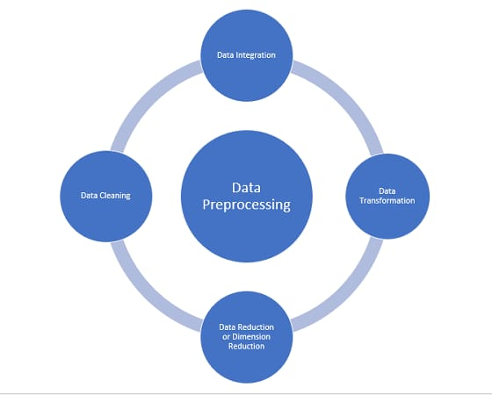

# Ensemble Methods:

Implement ensemble methods like Random Forest or Gradient Boosting to combine multiple models for better accuracy.

# Deep Learning Architectures:

Develop deep learning models using neural networks, such as convolutional neural networks (CNNs) or recurrent neural networks (RNNs), to capture complex patterns in the data.

Design the architecture with careful consideration of the data and the problem.

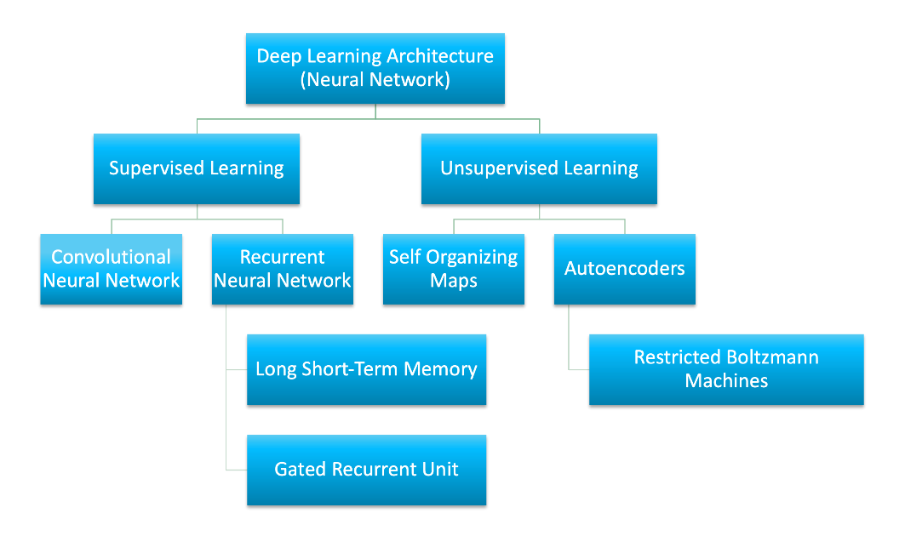

# Hyperparameter Tuning:

Utilize techniques like grid search or random search to find optimal hyperparameters for your models.

Consider techniques like Bayesian optimization for more efficient hyper parameter tuning.

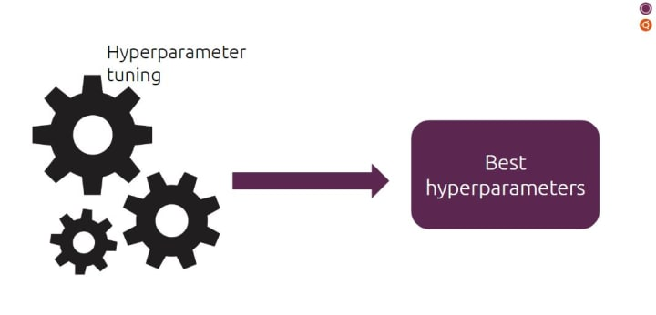

**6.Model Training:**

Split the data into training, validation, and testing sets.

Train your models on the training data while monitoring performance on the validation set.

# Evaluation Metrics:

- Choose appropriate evaluation metrics, like Mean Absolute Error (MAE) or Mean Squared Error (MSE), depending on your specific problem.

# Feature Engineering:

* Continuously refine and improve feature engineering to capture more relevant information.
* Explore advanced techniques such as Principal Component Analysis (PCA) or t-SNE for dimensionality reduction.

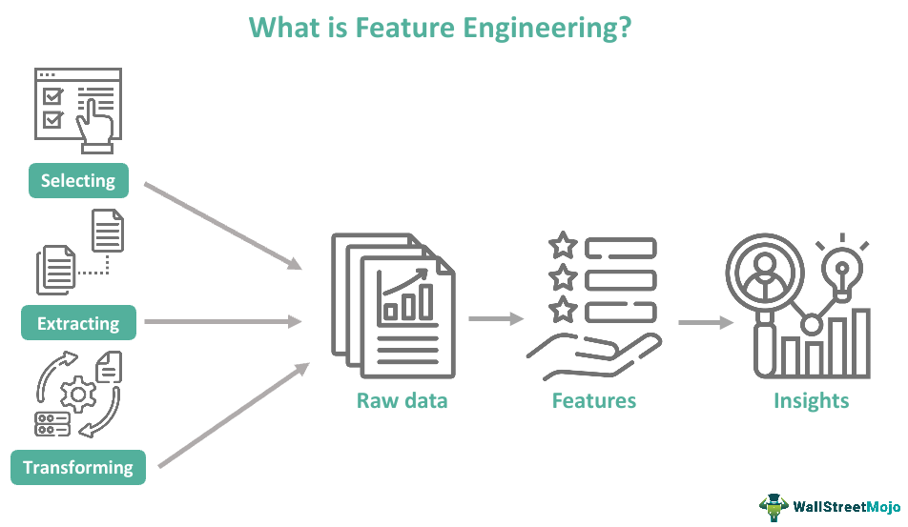

# Regularization:

Apply techniques like dropout and L2 regularization to prevent overfitting, especially in deep learning models.

# Ensemble of Ensemble:

Consider building an ensemble of your ensemble models to improve prediction performance further.

# Deployment and Monitoring:

Deploy your model in an environment suitable for earthquake monitoring. Continuously monitor and update the model as new data becomes available.

**Conclusion** :

Earthquake prediction is extremely complex, and even with advanced machine learning techniques, precise short-term earthquake prediction remains a significant challenge. This process focuses more on earthquake activity analysis and anomaly detection, which can provide valuable insights for early warning systems and disaster preparedness.